**DATA STRUCTURES**

**Day 1:**

**Data**:

A simply set of value are called data.

**Group Item:**

A data items that are divided into subitems are called group data (e.g., Employee is a data item and it can be divided into subitems like first name, last name, gender, age etc.)

**Elementary Item:**

A data item that are not divided into subitems are called Elementary items (e.g., Emp Id etc.)

**Information:**

The processed or meaningful data is called information. Information is sometimes used for data with giver attribute data are organized into the hierarchy of fields, records and files reflects the relationship between attributes and entity sets.

***Field*** is a single entity unit of representing an attribute of and entity.

***Record*** is the collection of field values of a given entity.

***File*** is a collection of records of the entities in a given entity set.

**Data Structure:**

**Why we use data structures?**

We use **Data structure** because it provides the right way to organize information in the digital space (computer memory) like a real world.

**What is data structure?**

The logical or mathematical model of particular organization of data is called a data structure.

**The study of data structures includes:**

* Logical / mathematical description of structure.
* Implementation of structure on computer.
* Quantitative analysis of data that includes amount of required memory to store structure and processing time.

**Consider following steps while choosing a data structure:**

1. Analyze the given problem to find check resources that a solution required.
2. Determine the basic operation must be supported and quantify required resources for them.
3. Select a data structure which meets the maximum requirements.
4. Structure should mirror the actual relationship in real world and it should be simple that effectively process the data when processed.

**Classification of Data Structures**

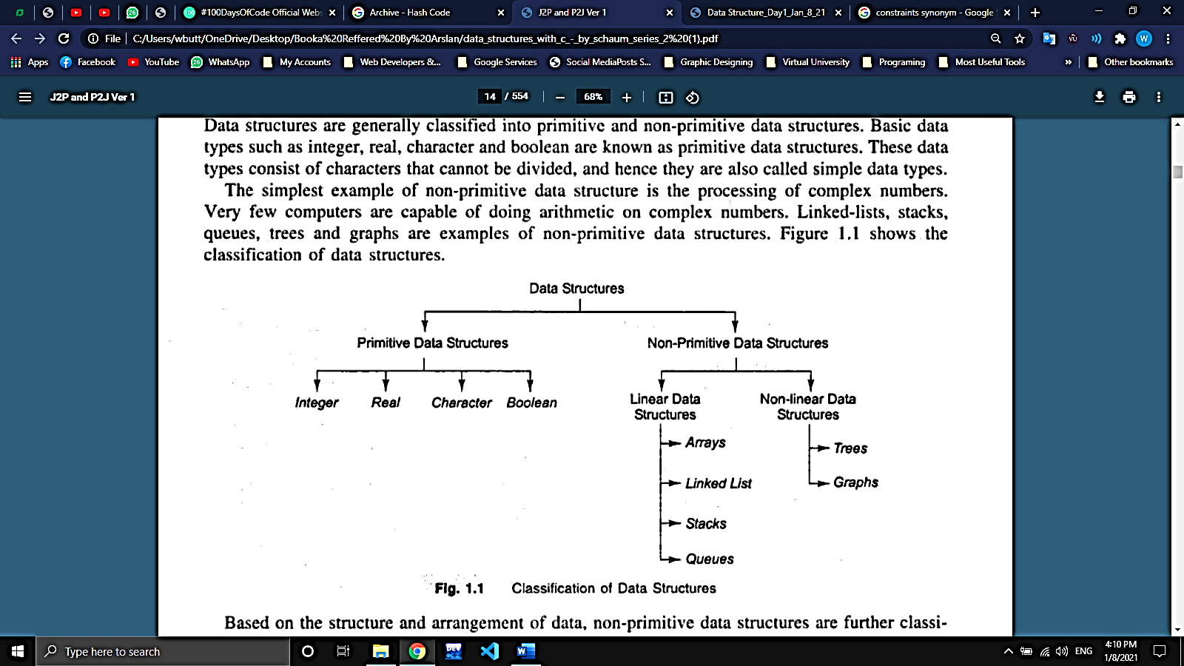Data Structures are generally classified into two types which are primitive and non-primitive data structures.

**Primitive Data Structures:**

Primitive Data Structures are the basic data structures that directly operate upon the machine instructions. It is also known as simple data types. Integers, Character, String and Pointers etc. come under this category.

**Note: A primitive data structure cannot be broken down into a simpler data type.**

**Non-Primitive Data Structures:**

Non-primitive data structures are more complicated data structures and are derived from primitive data structures. They emphasize on grouping same or different data items with relationship between each data item. e.g., **Arrays**, **Lists** etc.

**Non-Primitive Data Structures can be Linear and Non-Linear:**

The element forms a sequence or linear list is called **Linear Data Structures. [Arrays, Lists, Stacks and Queues].**

The element that doesn’t form a sequence is called **Non-Linear Data Structures. [Trees and Graphs]**

**Data Structure Operations:**

Data structure can be processed by different operations. The following operations are the major operations:

1. ***Traversing:*** Accessing each record exactly once (is also called visiting the record)
2. ***Searching:*** Finding the location of a record or all records with given key value.
3. ***Inserting:*** Adding a new record to the structure.
4. ***Deleting:*** Removing a record form the structure.
5. ***Sorting:*** Arranging a record in logical order.
6. ***Merging:*** Combining a record into two different files or more in to a single record file.

**! Task Completed**